2023– PRIVATE JOURNEYS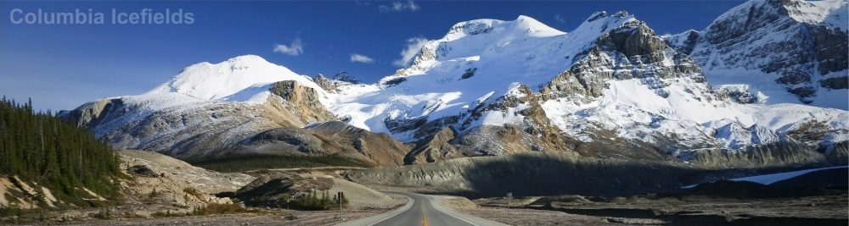
WESTERN CANADA | 6 NIGHTS & 7 DAYS
Highlights: Daily Breakfast, FlyOver Canada, Vancouver City Tour, Kelowna, Lake Louise, Glacier Adventure & Glacier Skywalk at Columbia Icefields, Banff Tour with Sulphur Mountain Gondola.

Day 01 – Vancouver
On arrival, transfer from Vancouver International Airport to hotel. Later you will be transferred to Hotel. Rest of the day at leisure. Overnight in Vancouver hotel.

Day 02 – Vancouver
After breakfast proceed on Vancouver City Tour. Explore the spectacular waterfront landmarks including Canada Place, Robson Street for shopping, English Bay, Stanley Park, Granville Island, Chinatown and Gastown. Afternoon, visit FlyOver Canada, a 4D show experiencing a gentle ride. Chairlift-style seats are elevated before a large spherical screen creating an illusion of flying over the landscapes. Overnight in Vancouver hotel.

Day 03 – Vancouver to Kelowna
After breakfast, check-out and transfer through the gardens, mountains and wineries of Western Canada. Driving to Kelowna is a refreshingly accessible and scenic outing. Add to that, well-maintained highways with 4 lanes most of the way and it's often a preferred choice. Journey alongside thousand-year-old glaciers and majestic mountain peaks to award winning wineries in the lush fruit growing Okanagan Valley. On the way visit Minter Gardens and through the exquisite gardens. An evening arrival at your selected Kelowna hotel allows time for exploration of the lakefront. Overnight in Kelowna hotel.

Day 04 – Kelowna to Lake Louise
After breakfast continue north through the Okanagan Valley to Vernon. Enjoy a short stop at Armstrong before continuing to Sicamous, the “Houseboat Capital of Canada”. Ascending Roger’s Pass, the summit of Glacier National Park and stop at the Spiral Tunnels. Shortly afterwards, enter Banff National Park and on to world famous Lake Louise, one of the most stunning emerald green lakes in the Canadian Rockies. Overnight in Lake Louise hotel.

Day 05 – Lake Louise to Banff via Columbia Icefields
After breakfast, check-out and transfer to Banff via the Icefields Parkway - Canada’s most scenic mountain roadway, a route to glaciers, lakes and waterfalls. Arrive at the Columbia Icefields Discovery Centre, take the Glacier Adventure which takes you up the Athabasca Glacier. Later take a coach from the Discovery Centre to the Glacier Skywalk, a glass-floored observation platform over the Sunwapta Valley for an unobstructed view of the surrounding glaciers. Continue along the Parkway to the Crowfoot Glacier, Peyto Lake and Bow Lake en route to Banff. Overnight in Banff hotel.

Day 06 – Banff
After breakfast proceed on Banff Tour. The resort town of Banff is set amongst the towering mountains of Rundle, Tunnel, Cascade and Norquay. Highlights include Bow Falls, Tunnel Mountain Drive, Surprise Corner, Hoodoos, Two Jack Viewpoint and Lake Minnewanka, where you can take an optional boat cruise for one hour which portraits the wildlife and vegetation including the Devil’s gap at foothills of the Rockies. A gentle ride on the Banff Gondola takes you to the summit of Sulphur Mountain for a 360 degree panorama of the Bow Valley. Afternoon at leisure to explore famous Banff Avenue. Overnight in Banff hotel.

Day 07 – Banff to Calgary Airport
After breakfast check-out out of the hotel and transfer to Calgary Airport to connect flight to onward destination.
INCLUSIONS & PRICING:

Inclusions:
- 06 Night accommodation in hotel
- 06 Breakfast at restaurant in the hotel
- Arrival transfers on private basis
- Inter-city transfers Vancouver-Kelowna-Lake Louise-Banff-Calgary Airport on private basis
- Sightseeing tours on private basis with local English speaking driver/guide
- Entrance fees to visit attractions as highlighted in the itinerary
- Departure transfers on private basis
- All taxes

Tour Price: May 01 – May 31
Value Hotels |  |  |  | Moderate Hotels |  |  |  | Deluxe Hotels
Vehicle Type | Twin | Triple |  | Vehicle Type | Twin | Triple |  | Vehicle Type | Twin | Triple
02-03 (SUV) | 6195 | 5985 |  | 02-03 (SUV) | 7045 | 6695 |  | 02-03 (SUV) | 7850 | 7385
04-06 (Sprinter) | 4345 | 4130 |  | 04-06 (Sprinter) | 5190 | 4840 |  | 04-06 (Sprinter) | 5995 | 5540
07-09 (Van) | 3190 | 2975 |  | 07-09 (Van) | 4040 | 3680 |  | 07-09 (Van) | 4840 | 4375

Tour Price: June 01 – October 31
Value Hotels |  |  |  | Moderate Hotels |  |  |  | Deluxe Hotels
Vehicle Type | Twin | Triple |  | Vehicle Type | Twin | Triple |  | Vehicle Type | Twin | Triple
02-03 (SUV) | 6440 | 6145 |  | 02-03 (SUV) | 7260 | 6835 |  | 02-03 (SUV) | 8155 | 7595
04-06 (Sprinter) | 4590 | 4290 |  | 04-06 (Sprinter) | 5405 | 4990 |  | 04-06 (Sprinter) | 6305 | 5740
07-09 (Van) | 3430 | 3135 |  | 07-09 (Van) | 4250 | 3830 |  | 07-09 (Van) | 5150 | 4590

Rates are per Person in Canadian Dollars.

Hotels:
City | Value | Moderate | Deluxe
Vancouver | Sandman Suites on Davie Vancouver | Sheraton Wall Centre | Fairmont Waterfront
Kelowna | Sandman Hotel & Suites Kelowna | Prestige Beach House | Delta Grand Okanagan Resort
Lake Louise | Lake Louise Inn | Fairmont Chateau Lake Louise | Fairmont Chateau Lake Louise
Banff | Banff Ptarmigan Inn | Rimrock Resort | Fairmont Banff Springs
Hotels and Rates are subject to availability at the time of booking.

Recommended Optional Tours/Admission:
City | Tour | Duration
Vancouver | Vancouver Scenic Float Plane Tour | 30 Minutes
Lake Louise | Lake Louise Lift | At Leisure
Banff | Minnewanka Boat Ride | 1.5 Hours

Departure: Daily.

Note:
- On Day 01 and Day 07 point-to-point (Airport to Hotel & vice versa) transfers only.
- Vehicle at disposal for 08 hours on day 02/03/04/05/06.
- Any type of mandatory fee like a resort fee / city tax etc. has to be paid at the hotel directly, the same in not a part of the package.
- Rates are based on minimum 02 passengers travelling together at all times.
- Attractions are subject to weather conditions.
- Rates are subject to availability at the time of booking.

