2023 – Shared Coach Service 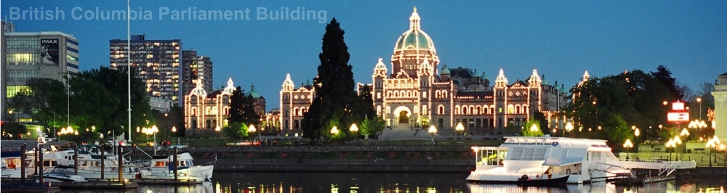
PACIFIC NORTHWEST | 4 NIGHTS & 5 DAYS
Highlights: Daily breakfast, Whistler Sea to Sky Highway, Peak 2 Peak Gondola, Vancouver City Tour and Lookout, FlyOver Canada, 90 Minute Ride on BC Ferries through Gulf Islands, Butchart Gardens.

Day 01 – Vancouver to Whistler
On arrival, avail your transfer from Vancouver Airport to Whistler city located in north of Vancouver in British Columbia. Travel along the Sea to Sky highway with breath-taking views, scenic ocean vistas, mountains, waterfalls and much more. On arrival, check-in at the hotel (as per the check in time). Rest of the day is at leisure. Overnight in Whistler hotel.

Day 02 – Whistler to Vancouver
After breakfast, check-out and keep luggage in the lobby. Its perfect time to explore the Whistler village on own. Follow the smells of fresh waffle cones to discover Whistler's best ice cream parlours, bistros and coffee shops. Proceed to take the exciting Peak 2 Peak Gondola, from Whistler village, spanning the distance between Whistler and Blackcomb’s peaks. Wait for the Silver Gondolas as they offer glass bottoms for the entire 360 degree experience. Later evening, transfer to Vancouver, on arrival check-in at hotel. Overnight in Vancouver hotel.

Day 03 – Vancouver
After breakfast, proceed on Vancouver City Tour to explore the spectacular waterfront landmarks including Canada Place, Robson Street for shopping, English Bay, Stanley Park, Granville Island, Chinatown and Gastown. Taking sightseeing to the next level, enjoy the incredible views from the top of the Harbour Centre Tower where you board a glass elevator for a 360-degree view at Vancouver Lookout observation deck for guided tour of Vancouver’s landmarks, attractions, history, and fascinating facts. Later evening, visit FlyOver Canada, a 4D show experiencing a gentle ride. Chairlift-style seats are elevated before a large spherical screen creating an illusion of flying over the landscapes. Overnight in Vancouver hotel.

Day 04 – Vancouver to Victoria
After breakfast, check-out and transfer to Victoria with a 90 Minute Ride on BC Ferries through Gulf Islands. On arrival, proceed to Butchart Gardens where magnificent gardens await you. Afternoon, check in at hotel. Later you will have ample time to explore the world famous Fairmont Empress Hotel, British Import Ships, Parliament Buildings and famous Inner Harbour. Overnight in Victoria hotel.

Day 05 – Victoria to Vancouver
After breakfast, free time to explore Victoria on own. Later transfer by coach and followed by a ferry to Vancouver Airport / Vancouver downtown to connect to onward destination.

INCLUSIONS & PRICING:

Inclusions:
- 04 Night accommodation in the hotel
- 04 Breakfast at restaurant in the hotel
- Inter-city transfers Vancouver-Whistler-Vancouver-Victoria-Vancouver on seat-in-coach basis
- Ferry transfers to and from Victoria
- Sightseeing tours on seat-in-coach basis with local English speaking driver/guide
- Entrance fees to visit attractions as per itinerary
- All taxes

Tour Price: May 01 – May 31 Tour Price: June 01 – October 31
Hotel Type | Single | Twin | Triple | Child  2-11 Years |  | Hotel Type | Single | Twin | Triple | Child  2-11 Years
Value | 2230 | 1555 | 1380 | 540 |  | Value | 2520 | 1700 | 1475 | 540
Moderate | 2830 | 1880 | 1630 | 595 |  | Moderate | 3215 | 2075 | 1760 | 595
Deluxe | 4000 | 2510 | 2125 | 620 |  | Deluxe | 4050 | 2550 | 2180 | 620
Rates are per person in Canadian Dollars.

Hotels:
City | Value | Moderate | Deluxe
Whistler | Pan Pacific Whistler Village Centre | Hilton Whistler Resort | Fairmont Chateau Whistler
Vancouver | Sandman Suites on Davie Vancouver | Sheraton Vancouver Wall Centre | Fairmont Waterfront
Victoria | Embassy Inn | DoubleTree By Hilton Hotel & Suites Victoria | Fairmont Empress
Hotels and Rates are subject to availability at the time of booking.

Recommended Optional Tours/Admission:
City | Tour | Duration
Whistler | Mountain ATV Tour | 2 Hours
Whistler | Zip Line Adventure Bear Tour | 2.5 Hours
Whistler | Tree Trek Canopy Walk | 2.5 Hours
Vancouver | Entrance to Capilano Suspension Bridge | At Leisure
Vancouver | Entrance to Grouse Mountain | At Leisure
Victoria | Return by Seaplane from Victoria to Vancouver | 40 minutes

Departure: Daily.

Note:
- Seat-in-coach sightseeing do not necessarily offer complimentary pick-up and drop-off from hotels. However, most of the downtown hotels has complementary pick-up.
- Any type of mandatory fee like a resort fee / city tax etc. has to be paid at the hotel directly, the same is not a part of the package and cannot be pre-paid.
- Transfers to & from “FlyOver Canada, Vancouver” attraction, on own arrangement.
- FlyOver Canada – operates from 1000 Hours to 2100 Hours
- Peak 2 Peak Gondola operates:
  - 27th May – 13th September Daily
  - 14th September – 12th October (Saturday & Sunday only)
- Seat-in-coach transfers have common pick & drop off points.
- For seat-in-coach transfer: Victoria Downtown (Victoria Bus Terminal) to Vancouver airport
(Duration 04 hours including Ferry)
Daily departures from Victoria will be from Bus terminal.

- For seat-in-coach transfer from Vancouver airport to Whistler downtown Duration 03 hours
Daily departures from Vancouver airport to Whistler Gateway Loop. From Gateway Loop guest’s will have to transfer on own to the respective hotel.
- For seat-in-coach transfer from Whistler downtown to Vancouver Downtown Duration 02 hours
Daily departures from Whistler Gateway Loop to Vancouver Downtown. (Drop off in Vancouver will be at Hyatt Regency hotel only). To & fro transfers from the pick up and drop off point will have to be managed by guest’s on own.

- For Victoria Tour: We take a Ferry Ride of 90 Minute on BC Ferries from Tsawwassen Ferry Terminal to arrive at Swartz Bay Ferry Terminal in Victoria. Further proceed to Butchart Gardens followed by a city tour.
- Please book departure flights from Vancouver post 2300 Hours
- Attractions are subject to weather conditions.
- Rates are subject to availability at the time of booking.

