2023 – Shared Coach Service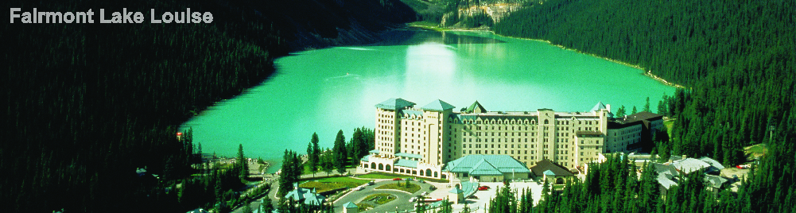
MAJESTIC ROCKIES (Calgary to Edmonton or Reverse) | 4 NIGHTS & 5 DAYS
Highlights: Daily Breakfast, Discover Banff and its Wildlife with Gondola, Lake Louise, Explore Jasper Tour, Glacier Adventure & Glacier Skywalk at Columbia Icefields.

Day 01 – Calgary Airport to Banff
On arrival, transfer from Calgary International Airport to Banff hotel. Check-in at the hotel and rest of the day is at leisure to explore famous Banff Avenue. Overnight in Banff hotel.

Day 02 – Banff to Lake Louise
After breakfast, check-out and keep luggage in the lobby. Proceed on Discover Banff and Its Wildlife tour with Gondola. The Town of Banff is an island of culture and history, surrounded by a sea of untamed wilderness. Highlights includes stop at the iconic Fairmont Banff Springs Hotel, Bow Falls, Lake Minnewanka and the “oh wow!” view at Surprise Corner. You’ll then be transported to the base of Sulphur Mountain and ride the Banff Gondola to the top of Sulphur Mountain for a 360 degree view of scenic mountain ranges. After your download on the Banff Gondola, our guide will transport you back to your Banff hotel. Later afternoon, transfer from Banff to Lake Louise. Rest of the evening at leisure to enjoy the charms of beautiful Lake Louise. Lake Louise, known for its turquoise, glacier-fed lake ringed by high peaks and overlooked by a stately chateau. Explore multiple optional activities like – Kayaking, Hiking trails wind up to the Lake Agnes, The Spa, Lake Louise Gondola and much more. Overnight in Lake Louise hotel.

Day 03 – Lake Louise to Jasper
After breakfast, check-out and travel through the Icefields Parkway - Canada’s most scenic mountain roadway, a route to glaciers, lakes and waterfalls. Arrive at the Columbia Icefields Discovery Centre, take the Glacier Adventure which takes you up the Athabasca Glacier. Later take a coach from the Discovery Centre to the Glacier Skywalk, a glass-floored observation platform over the Sunwapta Valley for an unobstructed view of the surrounding glaciers. Continue along the Parkway to the Crowfoot Glacier, Peyto Lake and Bow Lake. Continue alongside the Sunwapta River and take a stroll at Athabasca Falls before a late afternoon arrival at Jasper. Overnight in Jasper hotel.

Day 04 – Jasper
After breakfast, proceed on Explore Jasper Tour. Jasper’s beauty and history is set amid some of the most rugged peaks in the Rockies. Highlights include Jasper town-site, Athabasca Viewpoint, Maligne Canyon and Maligne Lake. At Maligne Canyon, stroll along 50 meter walls and learn about its unique underground water system. Afternoon, free time to explore optional activities like White Water Rafting, Jasper Skytram, Cruise on Maligne Lake, Sky Gazing and much more. Overnight in Jasper hotel.

Day 05 – Jasper to Edmonton (5 Hours)
0630 Hours: Check-out and avail early morning transfer to Edmonton Airport for a late afternoon flight to connect to onward destination.

INCLUSIONS & PRICING:

Inclusions:
- 04 Night accommodation in the hotel
- 03 Breakfast at restaurant in the hotel (No breakfast in Jasper on last day as guest’s depart early morning)
- Inter-city transfers Calgary-Banff-Lake Louise-Jasper-Edmonton on seat-in-coach basis
- Sightseeing tours on seat-in-coach basis with local English speaking driver/guide
- Entrance fees to visit attractions as per itinerary
- All taxes

Tour Price: May 01 – May 31 Tour Price: June 01 – October 31
Hotel Type | Single | Twin | Triple | Child  2-11 Years |  | Hotel Type | Single | Twin | Triple | Child  2-11 Years
Value | 2095 | 1540 | 1460 | 555 |  | Value | 2510 | 1745 | 1595 | 555
Moderate | 3060 | 2070 | 1930 | 610 |  | Moderate | 3480 | 2280 | 2070 | 610
Deluxe | 4675 | 2930 | 2740 | 665 |  | Deluxe | 4945 | 3065 | 2830 | 665
Rates are per person in Canadian Dollars.

Hotels:
City | Value | Moderate | Deluxe
Banff | Banff Ptarmigan Inn | Rimrock Resort | Fairmont Banff Springs
Lake Louise | Lake Louise Inn | Fairmont Chateau Lake Louise | Fairmont Chateau Lake Louise
Jasper | Lobstick Lodge | Chateau Jasper | Fairmont Jasper Park Lodge
Hotels and Rates are subject to availability at the time of booking.

Recommended Optional Tours/Admission:
City | Tour | Duration
Banff | Minnewanka Boat Ride | 1.5 Hours
Lake Louise | Lake Louise Lift | At Leisure
Jasper | Maligne Lake Cruise | 1.5 Hours
Jasper | Whitewater Rafting Tour | 2.5 Hours
Jasper | Jasper Skytram / Tramway | At leisure

Departure: Daily.

Note:
- Seat-in-coach sightseeing do not necessarily offer complimentary pick-up and drop-off from hotels. However, most of the downtown hotels has complementary pick-up.
- For Calgary to Edmonton Route, please look for flights out of Edmonton after 1500 Hours.
- For Edmonton to Calgary Route, please look for flights arriving into Edmonton by 1300 Hours.
- Any type of mandatory fee like a resort fee / city tax etc. has to be paid at the hotel directly, the same is not a part of the package and cannot be pre-paid.
- Attractions are subject to weather conditions.
- Rates are subject to availability at the time of booking.

